

Practices for Secure Software Report

Table of Contents
Document Revision History 3
Client 3
Instructions 3
Developer 4
1. Algorithm Cipher 4
2. Certificate Generation 4
3. Deploy Cipher 4
4. Secure Communications 4
5. Secondary Testing 4
6. Functional Testing 4
7. Summary 4
8. Industry Standard Best Practices 4

Document Revision History

Version | Date | Author | Comments
1.0 | 04/18/2026 | Marcelo Barbosa | Completed secure software report draft.

Client



Instructions

Submit this completed practices for secure software report. Replace the bracketed text with the relevant information. You must document your process for writing secure communications and refactoring code that complies with software security testing protocols.

- Respond to the steps outlined below and include your findings.
- Respond using your own words. You may also choose to include images or supporting materials. If you include them, make certain to insert them in all the relevant locations in the document.
- Refer to the Project Two Guidelines and Rubric for more detailed instructions about each section of the template.

Developer
Marcelo Barbosa

Algorithm Cipher

I recommend using TLS with modern certificates for communications and SHA-256 to verify the integrity of transferred data. TLS protects data in transit by encrypting the connection between the client and server, while SHA-256 provides a reliable way to verify that data has not been altered. This combination is appropriate for the project because Artemis Financial is handling sensitive financial information and needs confidentiality, integrity, and trust during communication.
SHA-256 is part of the SHA-2 family of hash functions and produces a 256-bit hash value. A hash function is not the same as encryption because it is designed to be one-way. This project makes it a good fit for checksum verification because the application can generate a digest from a string of data and then compare it later to confirm that the content has not been altered. A 256-bit output gives a very large number of possible combinations, which helps protect against collisions and makes the checksum more dependable than older algorithms such as MD5 or SHA-1.
For secure communications, the application also relies on asymmetric and symmetric cryptography, with TLS providing the transport layer. During the initial handshake, asymmetric cryptography with a certificate is used to verify the server's identity and securely exchange key material. After that, symmetric session keys are used because symmetric encryption is much faster and more practical for sending data back and forth during the active session. Random numbers are important in this process because modern TLS sessions depend on securely generated random values to create unique session keys and reduce the risk of replay or prediction attacks.

Certificate Generation
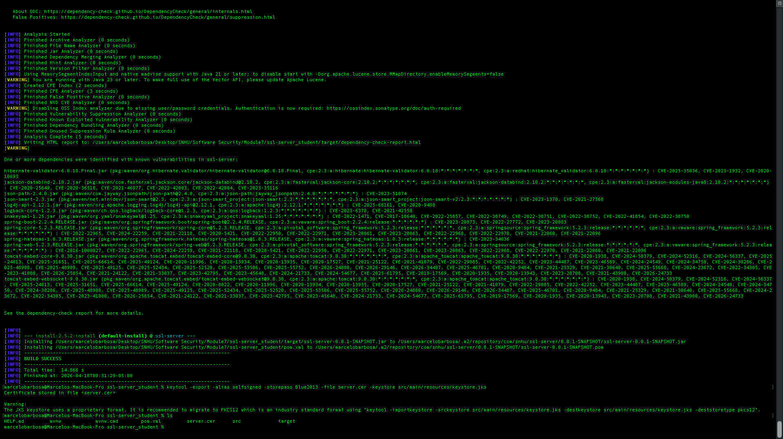
I have generated a self-signed certificate with the Java Keytool so the Spring Boot application could serve content over HTTPS during local development. After creating the keystore, I exported the certificate as a CER file to verify that the certificate was created correctly and could be referenced in the report evidence.

Deploy Cipher
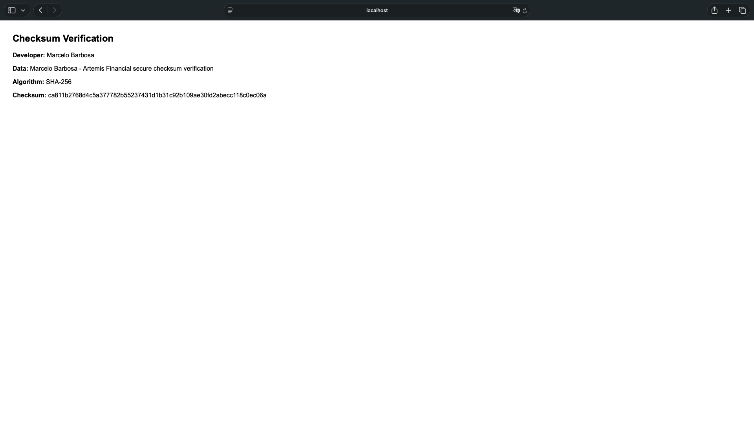
To deploy the checksum functionality, I refactored the application to expose a /hash endpoint that builds a unique data string containing my name and project-specific text, then computes a SHA-256 digest using Java's MessageDigest class. This supports Artemis Financial's requirement for a file verification step because the endpoint returns both the original data and the resulting checksum, making the integrity check visible and testable.

Secure Communications

I updated the application configuration, so the service runs on HTTPS instead of plain HTTP by binding the server to port 8443 and referencing the local keystore. After the application was compiled and started, browsing to https://localhost:8443/hash displayed the checksum page over a secure connection. This step adds transport-layer protection and confirms that data is being served through an encrypted channel.

Secondary Testing
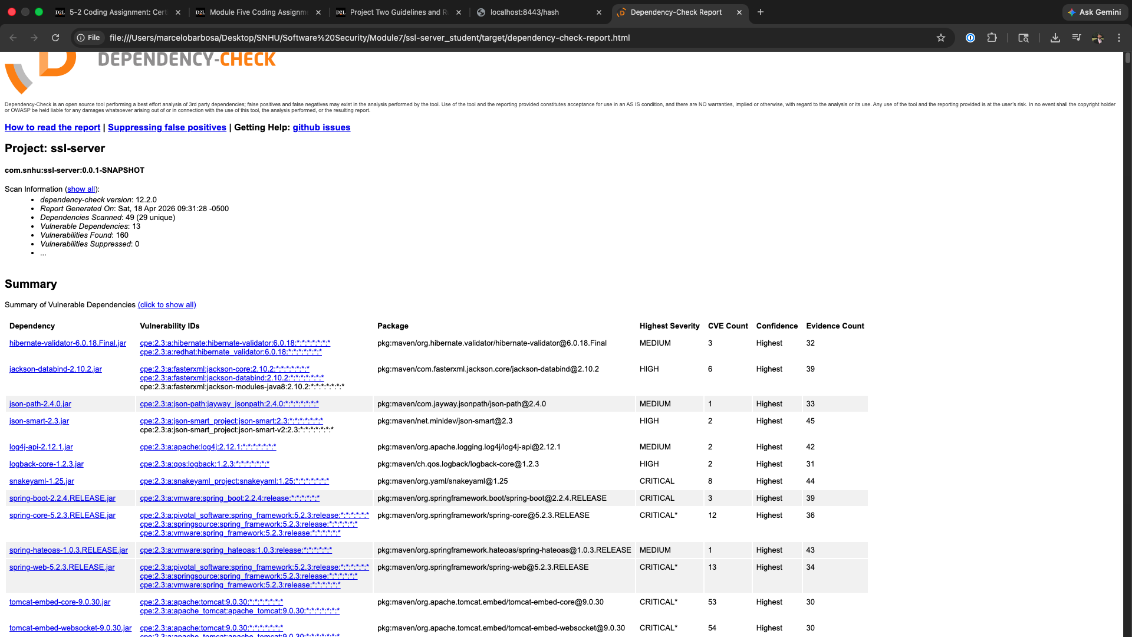
After refactoring the code, I ran the OWASP Dependency-Check against the project to confirm that the code changes did not introduce new known vulnerabilities through dependencies. For this project, the focus is on validating the security of the refactored components and reviewing the generated report for any new findings that would require remediation.

Functional Testing
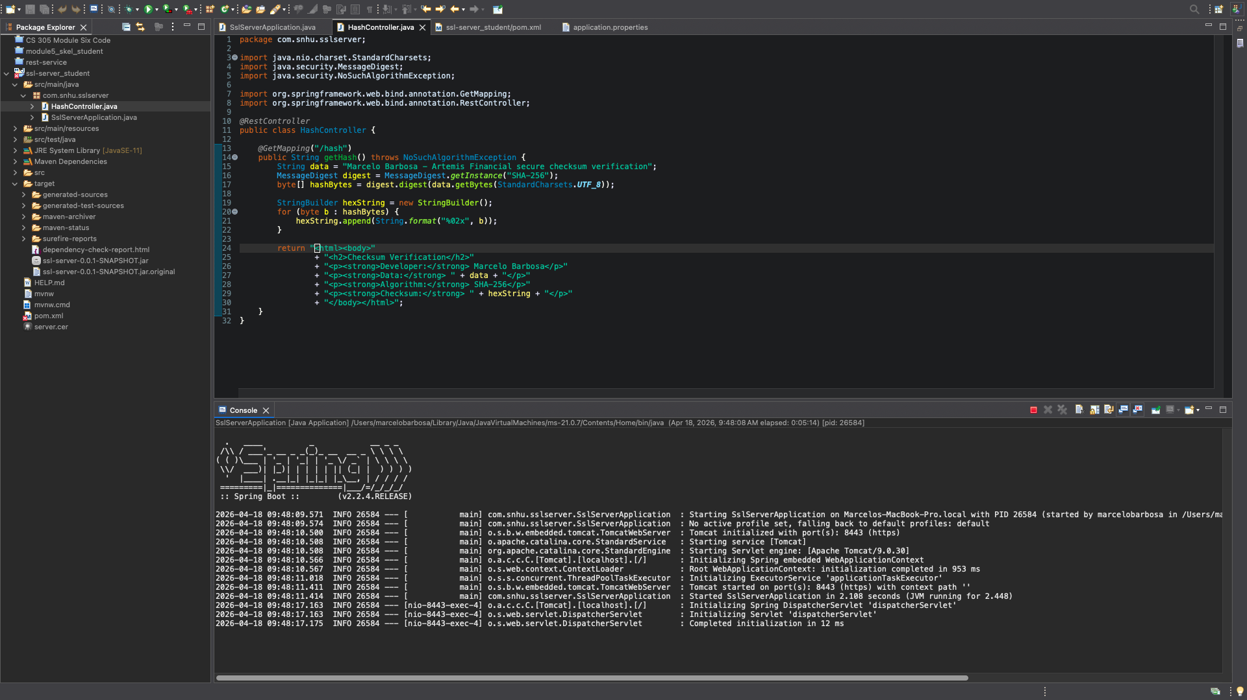
For functional testing, I manually reviewed the code for syntax, logic, and security issues and verified that the refactored endpoint behaves as expected. The main checks included confirming that the application starts cleanly, that the /hash route returns the expected data and checksum, that the hashing logic uses a current algorithm, and that the HTTPS configuration points to the correct keystore and port. This type of review helps catch mistakes that automated tools may not fully explain, such as incorrect endpoint behavior, misconfiguration, or insecure coding patterns.

Summary

I refactored Artemis Financial's application by adding a checksum verification endpoint, preparing it for HTTPS communication, and reviewing the code for secure implementation choices. These changes directly addressed the cryptography and client/server areas in the vulnerability assessment process flow diagram by strengthening data integrity verification and securing communications between the browser and the application. The work also touched the code error and code quality areas because the refactoring required a manual review of the new logic, route behavior, and the configuration used for secure transport.

Industry Standard Best Practices

To maintain the application's existing security while improving it, I applied industry-standard secure coding practices by using a current hash algorithm instead of older, broken alternatives, limiting the refactoring to the required checksum feature, and configuring the application to use HTTPS rather than leaving communication exposed over plain HTTP. I also kept the implementation simple and readable so the new code could be reviewed more easily and maintained with less risk of introducing logic errors.
Applying industry-standard best practices benefits Artemis Financial beyond this one assignment. Secure coding reduces the risk of data exposure, helps preserve customer trust, lowers the likelihood of costly remediation later, and supports a stronger long-term software development process. For a financial services client, these practices are especially valuable because confidentiality, integrity, and system reliability all affect the company's reputation and the protection of customer information.

